Help us re-stock Food Ministry!

The ministry can use any item you would like to donate (food, toiletries, etc.) with the exception of medicine. Reach out to Sheila with any questions!
FOOD items to donate:

Dried Packaged Food:
*Breakfast Cereal
Oatmeal in containers
Sugar
Maseca (corn flour)
*Meal kits (eg macaroni and cheese, hamburger helper)
Pasta/spaghetti 16 oz
*Pinto Beans, Dried (any size)
Rice (any size)

Canned or Bottled Foods:
Chicken 13 oz
Canned Fruit 15 oz
*Jelly (not grape)
Peanut butter
Tuna fish 5 oz
Tomatoes (Crushed or Diced) 28 oz
Corn 15 oz
Canned Vegetables
*Refried Beans
Spaghetti Sauce 24/28 oz
Black Beans 15 oz
*Hearty soups
Green Beans 14 oz
OTHER items to donate for guests:

Toiletries:
Soap
Shampoo
Deodorant
Toothbrush/toothpaste

Paper goods:
Paper towels
Toilet paper

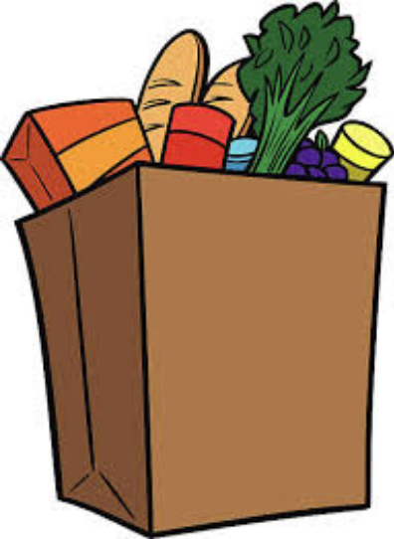
OTHER items to donate for pantry:
Hand sanitizer
Lysol/ cleaning wipes
Face masks

