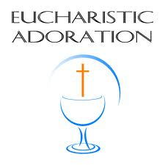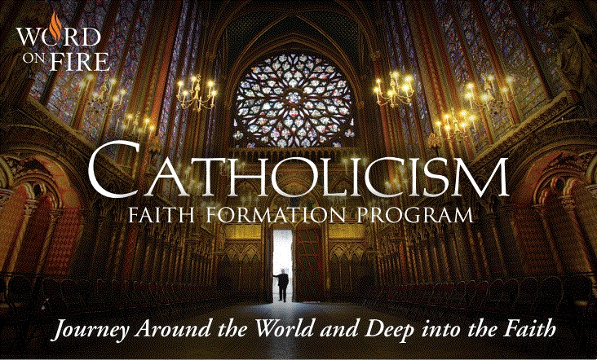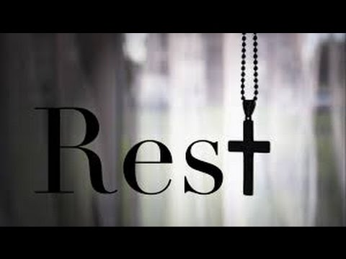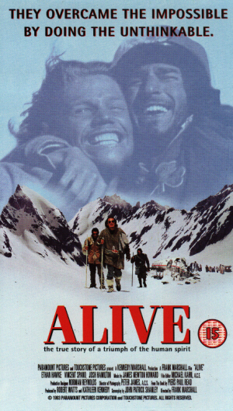  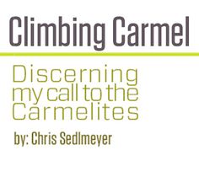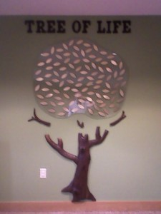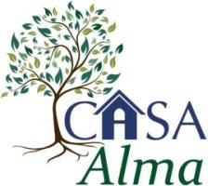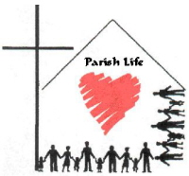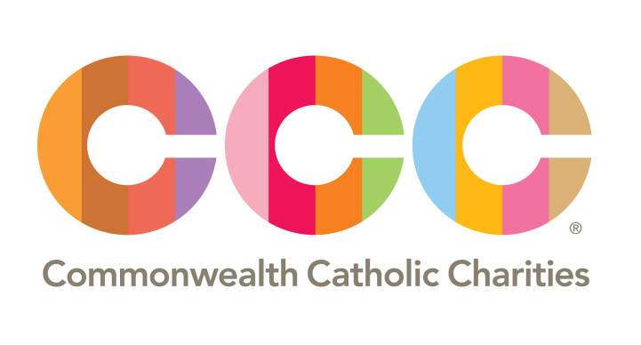 Macintosh HD:Users:israelm:Desktop:image005.jpg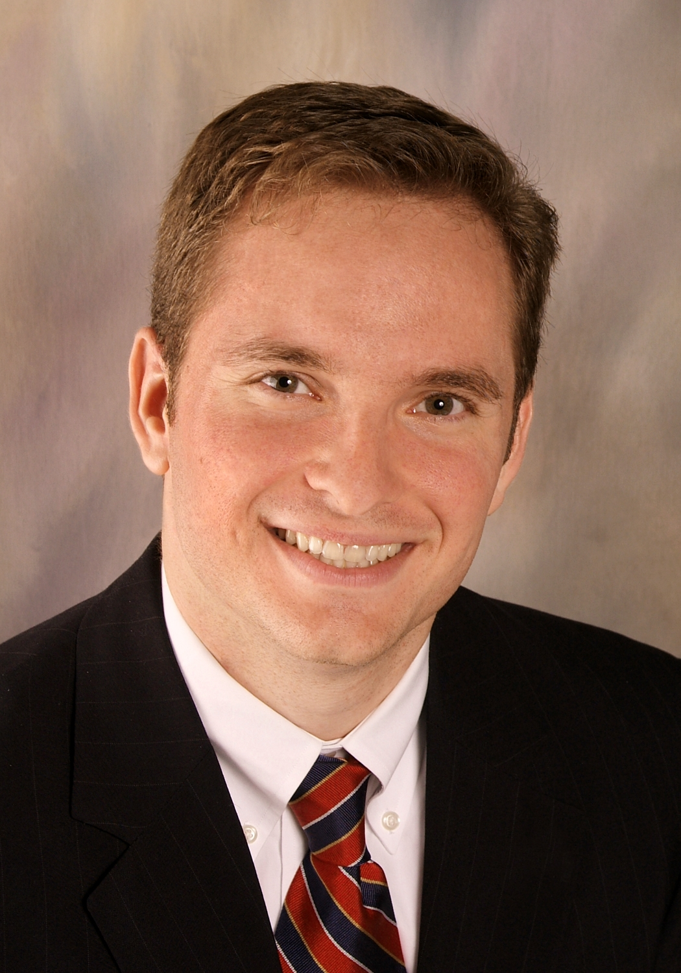

***Growing in Christ and Living Our Faith through Relationships***

*Exposition of the Blessed Sacrament*

*Thursday, 1:00 – 8:00pm*

**VBS: Vacation Bible SAINTS!**

Vacation Bible Saints will be held at Incarnation Monday-Friday, July 24-28 from 9:00 am until 12:00 pm each day.  Come learn about some of our beloved Catholic Saints through crafts, music, games, and other activities.  All rising kindergarten through 5th grade children are invited to participate.  Suggested donation of $25 per family to attend.  We are also looking for middle and high school students and adults to serve as leaders.  Please contact Patrick with questions (patrickd@incarnationparish.org).

**Christian Formation Classroom Supplies are needed!**

If you would like to make a contribution of supplies, a complete list of needed items can be found at the link below. Or, our most used supplies are crayons, markers, tape, glue, hand sanitizer, construction paper, and other similar items. Thank you for your generosity and continued support of the Christian Formation Ministry!

[www.SignUpGenius.com/go/30E0F48A9AA29A7FE3-christian](http://www.signupgenius.com/go/30E0F48A9AA29A7FE3-christian" \t "_blank)

**ADULT FORMATION OPPORTUNITY:** Constitutive to our Christian religion is the fact that it is a *communal* faith. Baptism into Christ baptizes us into His Body, the Church. On Sunday, July 16, between the morning Masses (starting at 10:15am), Father Gregory will show a film on **The Mystical Union of Christ and the Church** in the Parish Activities Center, part of the Catholicism series created by Bishop Robert Barron. Bishop Barron explores the Catholic faith’s unique understanding of the relationship of Jesus Christ and the Church, how the Mystical Body of Christ is a living organism that stretches throughout the world, embracing humanity in all of its joys and sorrows. Grab a cup of coffee and come on over! All are welcome.

**PARISH SUMMER READING**

All parishioners are invited to read the book Drunks and Monks by John H. Carmichael, an autobiographical story dealing with the drama of divorce, caring for the gravely ill, recovering from addictions of various sorts, post-traumatic growth, and the role of religion and spirituality in modern life.  The book has been described by many as profound and life changing, and it may help you to develop a deeper appreciation for our Catholic faith.  Copies can be ordered from the Sycamore Tree.

**July 9, 2017 ~ 14th Sunday in Ordinary Time**

Readings: Zechariah 9:9-10–Romans 8: 9, 11-13–Matthew 11:25-30

**OFFICE HOURS:** 8:30am–4:30pm Monday –Friday

(Closed: 12:20–12:50pm daily)

Liturgy Schedule:

Monday–Friday: Mass times on page 2

Friday: 7:30pm, Español

Saturday: 5:30pm

Sunday: 9:00am, 11:30am & 4:30pm – English

1:30pm- Español

Nursery: 9:00am, 11:30am & 1:30pm

Sacrament of Reconciliation:

Saturday 4:30–5:00pm or by appointment

Sunday 12:45-1:15pm & Friday 8:30pm (Español)

We marvel at how God's mercy, presence, and grace breaks in to the lives of ordinary people in good times and in crisis. That is what we see in the films that we view and discuss at our parish TNT (Theater ‘N’ Theology). Our next TNT takes place on *Friday,* *July 14,* beginning promptly at 7:00pm. All are welcome to come to our **Incarnation Movie Theater** (the “Stone Chapel”) with comfortable seating and large projection. After the movie (the “Theology” part), we discuss the film’s relevance to our life in Christ and note the action of God’s mercy. Our July feature is the 1993 film Alive!. It's about the rugby team that survived 72 days in the Andes Mountains when their plane crashed on its way from Uruguay to Chile. It is a movie that is physically impressive beyond the astonishing particulars of its story. Unquestionably the most chilling portrayal of a plane crash in movie history. Starring Ethan Hawke and Vincent Spano. Rated R. Facilitated by Fr. Gregory. All are welcome. Come watch a great movie with your brothers and sisters in Christ!

A ROMAN CATHOLIC COMMUNITY • 1465 INCARNATION DRIVE • CHARLOTTESVILLE, VIRGINIA 22901

**Office Phone:** (434) 973-4381 **Fax:** (434) 973-1757 **E-Mail:** [office@incarnationparish.org](mailto:office@incarnationparish.org) **Website:** [www.incarnationparish.org](http://www.incarnationparish.org)

***Fr. Gregory Kandt,*** *Pastor* ***~ Fr. Jaime Guardado Delgado****, Parochial Vicar*

***Rev. Mr. Christopher Morash****, Deacon ~* ***Rev. Mr. Thomas Healey****, Deacon*

**FINDING A MASS WHILE ON VACATION**

You can check the website for the diocese you will be visiting.  You can also visit MassTimes.org, where you simply type the zip code you will be visiting in the box at the top and press enter.  A list of churches closest to the zip code, along with scheduled Mass times appears.  One note:  It's a good idea to also check the parish's website to verify the time.

**CHRISTIAN FORMATION REGISTRATION IS NOW OPEN!**

The forms are available for download here:

[http://incarnationparish.org/youth-formation/](http://incarnationparish.org/youth-formation/" \t "_blank)

*We welcome all visitors and invite you to join us in the Parish Hall for coffee & donuts after the 9:00am Sunday Mass.*

**Scheduled Litnics**

**Wednesday, July 12, at 6:30pm** Kathleen & Aaron Olowin will host a litnic at their home in Charlottesville. Please RSVP (434-975-3605) and let them know what you are bringing.

**Thursday, August 3, at 6:30pm** Fran Ingram will host a litnic in her home in Charlottesville. Please RSVP (434-296-1185) and let her know what you are bringing.

**MASS INTENTIONS: July 8-16**

Saturday 8: 5:30 Deborah Koehl

(Karen & Jim Lansing)

Sunday 9: 9:00 Bob Niehaus

(Nancy & Tom Strassburg)

11:30 Carlo Rizzo

(Rose Trapnell)

1:30 Missa Pro Populo

4:30 Missa Pro Populo

Monday 10: 12:15 The Rives

Tuesday11: 12:15 Pat & Howard Wilson-Special Intention

(Eithna Sullivan)

Wed’day 12: **6:30\*** Missa Pro Populo

Thursday 13: 12:15 Missa Pro Populo

Friday 14: 12:15 Mark Sullivan - Special Intention (Anonymous)

Saturday 15: 5:30 Arthue Crocker

(Coppola Family)

Sunday 16: 9:00 Paul & Angela Mahoney

(Cottrell Family)

11:30 Louise Kane

(Karen Lansing)

1:30 Missa Pro Populo

4:30 Kathy Spradling

(Cindy & Doug Campbell)

**6:30\* Litnic- See schedule below for details**

Summer is coming at Incarnation and that means it’s time to get your house ready for a LITNIC. A venerable Incarnation tradition, a LITNIC is a LITurgy-picNIC. An interested household signs up to host a litnic and Catholics in the neighborhood are encouraged to come. Fr. Gregory comes and presides at Mass at the host home, those who come bring something to share at the meal that follows. Although especially intended to bring Catholics in a neighborhood together, litnics are open to all parishioners who want to attend. Litnics are family events. If you are interested in hosting a litnic and want to find out more about them, contact the Parish Office for LITNIC GUIDELINES. Dates for litnics are published each week in the bulletin; for those who want to host, sign up for a date with the Parish Office, first-come, first-served. Litnics ordinarily begin at 6:30pm, but the time is negotiable with Fr. Gregory. Remaining Litnic dates for the 2017 season are:

July 18, 26.

**Call the Parish Office (973-4381) now and sign up!**

**COME AND SEE VOCATION WEEKEND**

July 14 at 9:00 am through July 16 at 5:00 pm

Join us for a weekend when single Catholic women come together to learn more about religious life from the women who live it! You will meet and talk with **Sisters of Bon Secours** in a relaxed environment. You will be surprised at how much you will get to know about religious life and how much you will enjoy being with the sisters. To register, call us at 410-442-3171.

**PRAYER WHILE AWAITING A NEW BISHOP**

Almighty God, Eternal shepherd and guide.  
In your love for us, Grant to the Diocese of Richmond  
A shepherd who will lead us  
To be Christ’s heart of mercy,  
Voice of hope, and hands of justice.

Help him to fill our minds and hearts  
With the truth of the Gospel,  
The power of the sacraments,  
And the desire to build up your holy Church.

We ask this through Christ our Lord. Amen.

Practical relativism consists in acting as if God did not exist, making decisions as if the poor did not exist, setting goals as if others did not exist, working as if people who have not received the Gospel did not exist.

--Pope Francis, The Joy of the Gospel #80

**EMPLOYMENT OPPORTUNITY:** Charlottesville Catholic School is seeking a part-time Aftercare Director and Aftercare assistants. This person(s) should have experience working with kids ages 4-13 and be available from 3:30-5:30 Monday through Friday. CPR certified and teaching experience is recommended but not required. Please contact Chris Tillson by email ([c.tillson@cvillecatholic.org](mailto:c.tillson@cvillecatholic.org" \t "_blank)) or phone [(434-964-0400 ext 388](tel:%28434%29%20964-0400" \t "_blank)) if you are interested.

**Charlottesville Catholic School ~ CCS**

[www.cvillecatholic.org](http://www.cvillecatholic.org) 434-964-0400

**SECULAR ORDER OF DISCALCED CARMELITE Community of Blessed Elizabeth of the Trinity meets at St. Francis Church in Staunton on the 2nd Sunday of each month. If you are interested in learning more or if you feel called to a Carmelite way of life,** please contact Lori Stevenson at 979-3175.

**WORSHIP**

Deacon Chris Morash: deaconchris@incarnationparish.org

CHURCH OF THE INCARNATION

***Bulletin printing sponsored by courtesy of Gary Albert, State Farm Agent 434-296-1222***

**TREE OF LIFE:** Have you considered honoring special occasions (birth, birthday, or anniversary) or memorializing a loved one, by making a donation for a leaf on our ***Tree of Life.*** The tree is located on the south wall of the Narthex. Enrollment forms are available next to the Tree of Life or in the Parish Office. Forms can be returned in the collection basket, to the Parish Office or mailed. Please make checks payable to Church of the Incarnation with Tree of Life on the memo line.

**JOIN US FOR FOOD-FUN-FELLOWSHIP**: Incarnation Night at  BAJA BEAN on Tuesday, July 18, 5:00-7:30pm, across from Sam’s Club. A portion of the proceeds help support our Parish! *Be certain to tell your waiter you’re supporting Incarnation!*

**PRAYER SHAWL MINISTRY**

The shawl serves as a mantle and sign of God's healing presence to strengthen someone who is weary, to ease their suffering and to comfort them when in pain or when they feel alone.  The shawls are made with love by parishioners.  Prayer shawls are available in the Parish Office. There is no cost for the shawl. Donations are accepted.

**Charlottesville Catholic Worker ~ Casa Alma**

[cvillecw@gmail.com](mailto:cvillecw@gmail.com)

**HELP NEEDED** with weekly weeding and other garden tasks. This summer we are hosting volunteer shifts on Monday and Friday mornings, and Wednesday and Thursday evenings.. No experience necessary. Contact us for more information!

**PRAY WITH US!** Every Wednesday morning, we greet the day with an ancient form of prayer, the *[Liturgy of the Hours](http://www.nccw.org/Public/Public/Commissions/Liturgy_of_the_Hours.aspx" \t "_blank).* All are welcome to join us for chanting the psalms, times of silence, and sharing our intentions. Prayer begins at 7:30am, concludes at 8:00am.

***MAKING PLANS FOR YOUR SUMMER VACATION?*** Don’t forget to include Incarnation in your summer plans! Sign up today for electronic transfer donations to make sure you remember your gifts to Church of the Incarnation. Just go our website to the “**Donate”** page and sign up. Thank you and have a happy and safe summer!

***To everything there is a season and a time***

***for every purpose under heaven . . .***

***“. . . a time to be born . . .”***

***“. . . a time to be healed . . .”***

James Armstrong, Ronald Balsam, Ann-Marie Balwinski, Meg Bojarski, Shauna Rose Boone, Diana Busch, Mary Jo Muir, Rose Byrne, Barbara Cage, Carla Campbell, Jude Campbell, Sarah Carreras, Mary Glenn Carrington, Rose Colasuonno, Pat & Richard Cook, Ken Cottrell, Anna May Cutitta, Becca Dameron, Esther Davis, Harry DeLeijer, Sue DeMong, Evans DiSantis, Melani Dinh, John Dovel, Alice Dunbar, Teal Estrada, Nancy Floyd, Fr. Jerry Fogarty SJ, Joe Frisina, Joann Harrell, Randy Hobbs, Jean Holienka, Eli Houston, Jerome Jareb, Atman Johnson, Helen Krespach, Genevieve Krynitsky, Tyler Lafferty, Mary Lederman, Alan Leidecker, Patty Lockwood, Vito Maltese, Ivy Maupin & Family, Kathleen McManus, Levi Miller, Jeff Mahoney, Kathy Milchus, Ron Mohr, Janice Moler, Patrice Moore, Joanne Niehaus, Ronald Olowin, Jack Ostrowski, Henry Oswald Sr., John Packett, John Reynolds, Chris & Jadea Riener, Joel Rivera, James Robins, Robert Ross, Jennifer, David & Amelia Scheer, Roger Scott, Perry Sennewald, Tom & Lynn Shepherd, Fran Slayton, Betty Smoyleak, Maureen Spokes, Denise Sprouse, Sandy Stevens, Craig Stotz, Debra Strzepek, Pat Stubbs, Nicholas Surat, Tom Tolman, Pat Velikov, Glenda Voelmeck, Kevin Ward, Linda Watson, Karen Will, Kathleen Yates, Marianne Zeigler

***“. . . a time to love . . .”***

***“. . . a time to die . ..”***

***“. . . and a time of peace .”***

Emily A. Bessler, Joshua Ostrowski,

Roberto Santamaria, David Waidelich, Joshua Wilson

**WE CELEBRATE THE LIFE OF OUR PARISH!**

Please let us know if you are new to the parish, are moving from it, are celebrating a significant event or are in need of prayers.

**MINISTRY OPPORTUNITY ~ SUNDAY FELLOWSHIP**

*Have friends told you that you have the gift of hospitality?*

***Do you enjoy creating a comfortable and welcoming atmosphere for people to get to know each other?***

**WHAT WE DO:** We take turns hosting coffee & donuts after the 9:00 and 11:30am Liturgy. This involves picking up the donut order at Dunkin’ Donuts, preparing lemonade and coffee, and serving those snacks after Mass. When we have only a few ministers, you’ll notice weeknds when we don’t have coffee & donuts after Mass.

**This is a sign that we need you!**

Your time commitment is one-half hour before and after Mass one Sunday per month. If you would like to join this ministry, please call Laure Taylor at 434-434-0148. We will pair you up with someone who will guide you through the process!

**Time Attendees**

5:30pm 140

9:00am 331

11:30am 252

1:30pm 368

4:30pm 137

**Total 1228**

**Mass Attendance**

**July 1/2**

**FINANCIAL RESOURCES**

**For the weekend of July 1/2**

Weekly amount needed for budget $ **22,290.00**

Offertory $ 9,069.81

Other Income $ 4,737.00

Total $ 13,806.81

**Difference - $ 8,483.19**

\*Based on FY 2017-18 budget of $1,159,102.00

***Offertory Envelopes distributed: 273 ~ Envelopes used: 121***

***Parishioners using Electronic Funds Transfer EFT: 137***

14th sunday in ordinary time

***Bulletin printing sponsored by courtesy of Gary Albert, State Farm Agent 434-296-1222***

juLY 9, 2017

, 2012

**FINANCIAL INDEPENDENCE:** Commonwealth Catholic Charities’ Housing and Financial Counseling services offer financial counseling to families and individuals. From improving credit scores, creating workable budgets, purchasing a home, or avoiding foreclosure, CCC’s certified housing and financial counselors can help individuals develop a plan to achieve financial goals and live with financial freedom. Learn more at [www.cccofva.org](http://www.cccofva.org" \t "_blank).

**LIFE PLANNING SEMINAR SERIES:** The Diocese of Richmond’s Center for Marriage, Family, and Life is hosting a three-part series intended for anyone who would like to learn how to anticipate common issues that might arise toward the end of life. The next seminar is on Tuesday, August 24 from 9:30am – 12:30pm. A panel of speakers will present practical guidance for how to care for an aging parent or spouse and what to consider when choosing among several long-term care options. There is no cost to attend and lunch is included with your free registration. Each session will be offered live at the Diocese of Richmond Pastoral Center and broadcast to satellite locations in the Western and Eastern Vicariates. Learn more and register at [www.cdrcmfl.org](http://www.cdrcmfl.org" \t "_blank) or call the office at [804-622-5109](tel:%28804%29%20622-5109" \t "_blank).

**DIOCESAN JOBS:** visit www.richmonddiocese.org/human. Click on “subscribe for job updates” to receive new notices.

https://ci6.googleusercontent.com/proxy/RnNZfQn2o2xpggJQqefCOervMbPIci5mujDPJnvl43kv6Rtxjyh5gHN_JKVzeU-aaGz3pePFgxfoAAtZJZNx8mveVTc-11j98EfuAJVcumUenA=s0-d-e1-ft#https://ssl.gstatic.com/ui/v1/icons/mail/images/cleardot.gif

**EVENTS & OPPORTUNITIES**

office@incarnationparish.org

**JUSTICE AND CHARITY MINISTRY**

Sheila Herlihy: sheila@incarnationparish.org

**MIGRANT MINISTRY:** Incarnation’s Migrant Ministry is having our first visit to the migrant camps this Wednesday, July 12. If you’re interested in joining us, or learning more about this ministry, please talk to Sheila.

**FOOD MINISTRY-INVITATION**: For our food ministry to function, we need people in a variety of roles.  Currently, we are looking for help with potential **home deliveries** of food to parishioners who can no longer make it to Incarnation. If you are interested in this or any other aspect of the ministry, contact Sheila in the Parish Office.  If you’d rather donate material goods, we accept all food items in the basket in the Narthex, (along with paper bags).  The item of the week is an easy way to add something small to your grocery list, and donate something that is very needed by our ministry.  This week, the item of the week is **hearty soups and spaghetti sauce.**

**OUTREACH MINISTRY UPDATE:** We are blessed in our parish to have generous donors for our many needs. Thank you to all who have donated egg cartons, we now have an abundant supply and are no longer accepting donations. **ALSO,** we don’t have the facility to accept donated clothing, please bring your donations to other thrift stores (Hinton Avenue Methodist Church has a free clothing closet, and Salvation Army provides clothing vouchers).

**GREEN TEAM EnvironMINUTE**: When you buy products, you can also encourage care for God’s creation. Buy recycled paper products (from post-it notes, to greeting cards, to paper plates) to use your purchasing power to protect creation.

**JUSTICE CORNER:** Making sure that young people have what they need is a value among many cultures. Several years ago, we discovered that here in Charlottesville, we didn’t have nearly enough child psychiatry for the need. Because we worked with other faith communities to make sure this became a priority, now God’s children have more than double the access they did before.

**HABITAT FOR HUMANITY BUILD DAYS:** Incarnation participates in the work of Habitat for Humanity, building houses for and with community members in need! No construction experience is necessary, and this is a great way to spend a Saturday living our faith and doing tangible work in the community. We also need people to photograph the event, and provide lunch. Our next build dates are July 15, September 16, and November 4. Please check out the sign-up sheets in the Narthex!

**Opportunities to GROW in Faith**

Did you know that as an alternative to our regular Christian Formation classes that occur on Sundays from mid September through the end of April, we offer an intergenerational program called FIRE here at Incarnation that is open to all.  **Family Intergenerational Religious Education (F.I.R.E.)** is done in small groups and based out of homes. Groups decide when and in what homes they will meet to complete approximately 16 lessons during the school year. Rather than dropping kids at several different class times on Sunday, everyone attends the same meeting at a time that’s convenient for the whole family.

FIRE is meant to be fun, for you, for your family, and for your group as you explore the experience of being "church" for each other and grow in closeness to the Lord.  Groups are formed during the summer, but generally don't start meeting until fall.  For more information, contact Al Reynolds ([al@incarnationparish.org](mailto:al@incarnationparish.org" \t "_blank)), the F.I.R.E. Coordinator.

Twinning with the Little Brothers and Sisters of the Incarnation, Pandiassou, Haiti

**Like a Good Neighbor, State Farm is There.**

***Auto – Home – Life – Health – Bank***

**Gary Albert CPCU CLU ChFC, Agent (Parishioner)**

**1380 Rio Road E – Charlottesvillle, VA 22901**

**Corner of Hillsdale Dr. & Rio Road East (1/4 mile from COTI)**

**BUS: 434-296-1222** [**insurance@garyalbert.com**](mailto:insurance@garyalbert.com)

*"Voted Charlottesville Family Favorite Insurance Agency 5 years in a row!"*